PASSW0RD POLICY IN AN ORGANIZATION

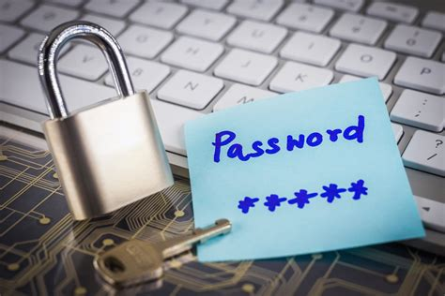

What is a Password Policy?

A password policy is a set of rules and guidelines designed to enhance computer security by encouraging users to create and implement stronger passwords.

**Why is Password Policy Important?**

A strong password policy is essential for any organization that wants to maintain a secure network environment. Passwords are the first line of defense against cyber attacks, and weak passwords can be easily compromised. Password policies help enforce password complexity and ensure that users create strong passwords that are difficult to guess or brute-force.

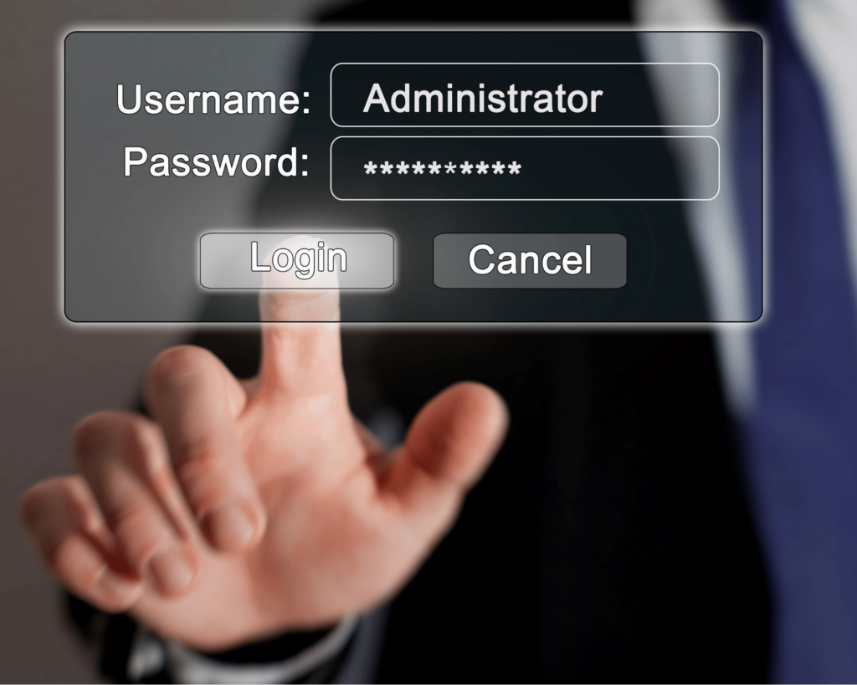

**Best Practices for Password Policy**

Creating and implementing a password policy is just the first step. It’s important to follow best practices to ensure that your password policy is effective. Here are some best practices to follow:

1. **Password Complexity Requirements**

Password complexity is a key component of any password policy. Passwords should have a minimum length of eight characters and include a combination of letters, numbers, and symbols. Passwords should not be easy to guess and should not contain common words, names, or personal information.

Enforce password complexity by requiring users to change their passwords regularly and prohibiting the reuse of previous passwords. The National Institute of Standards and Technology (NIST) recommends using passphrases instead of passwords. A passphrase is a combination of words that are easy to remember but difficult to guess.

1. **Ban the Use of Common Passwords**

One of the most important password requirements is to ban the use of common passwords. Common passwords such as “password,” “123456,” and “qwerty” are easily guessable and can be easily compromised. Educate users not to reuse organization passwords anywhere else.

1. **Implement Two-Factor Authentication**

Two-factor authentication (2FA) adds an extra layer of security to password authentication. It requires users to provide two forms of identification before gaining access to a system or network. This can be a password and a token, a password and a fingerprint, or a password and a security question. 2FA can prevent unauthorized access even if a password is compromised.

1. **Password Expiration**

Passwords should expire after a certain period to ensure that users update them regularly. The [NIST](https://www.nist.gov/) recommends a password expiration period of no more than one year. Users should be required to change their password before the expiration period, and they should not be allowed to reuse previous passwords.

1. **Password Storage**

Passwords should be stored securely to prevent unauthorized access. Passwords for service accounts and test accounts must be securely generated, distributed securely to the account owner, and stored securely in a password manager. Passwords must be changed upon suspicion or confirmation of compromise.

**Password Managers**

In addition to following a strong password policy, using a password manager is another best practice to enhance your password security. Password managers are software applications that store and manage all of your passwords in an encrypted database. Instead of remembering multiple complex passwords, you only need to remember one master password to access all of your other passwords.

**Using a password manager has several benefits:**

1. **Strong Password Generation**

Password managers can generate strong, complex passwords for you automatically. These passwords are difficult to guess or brute-force and are unique for each website or application you use. This reduces the risk of password reuse and prevents hackers from accessing multiple accounts if one password is compromised.

1. **Secure Storage**

Password managers store your passwords in an encrypted database that can only be accessed with your master password. This database is stored locally on your computer or in the cloud, depending on the password manager you use. By storing your passwords in a secure location, you reduce the risk of unauthorized access and data breaches.

1. **Easy Access**

With a password manager, you only need to remember one master password to access all of your other passwords. This makes it easy to use strong, complex passwords without having to remember them all.

1. **Cross-Device Syncing**

Many password managers offer cross-device syncing, which means you can access your passwords on multiple devices such as your computer, phone, or tablet. This ensures that you always have access to your passwords, no matter where you are.

1. **Autofill**

Password managers can also autofill your login credentials for you, saving you time and effort. This feature is especially useful for websites and applications that you use frequently.

While password managers can be a useful tool to enhance your password security, it’s important to choose a reputable and trustworthy password manager.